DSA BY LOVE BABBAR

Lecture 5 . operators , for loop , operator precedence and variable scoping

1. Difference between product and sum of the digits of the numbers

<https://leetcode.com/problems/subtract-the-product-and-sum-of-digits-of-an-integer/>

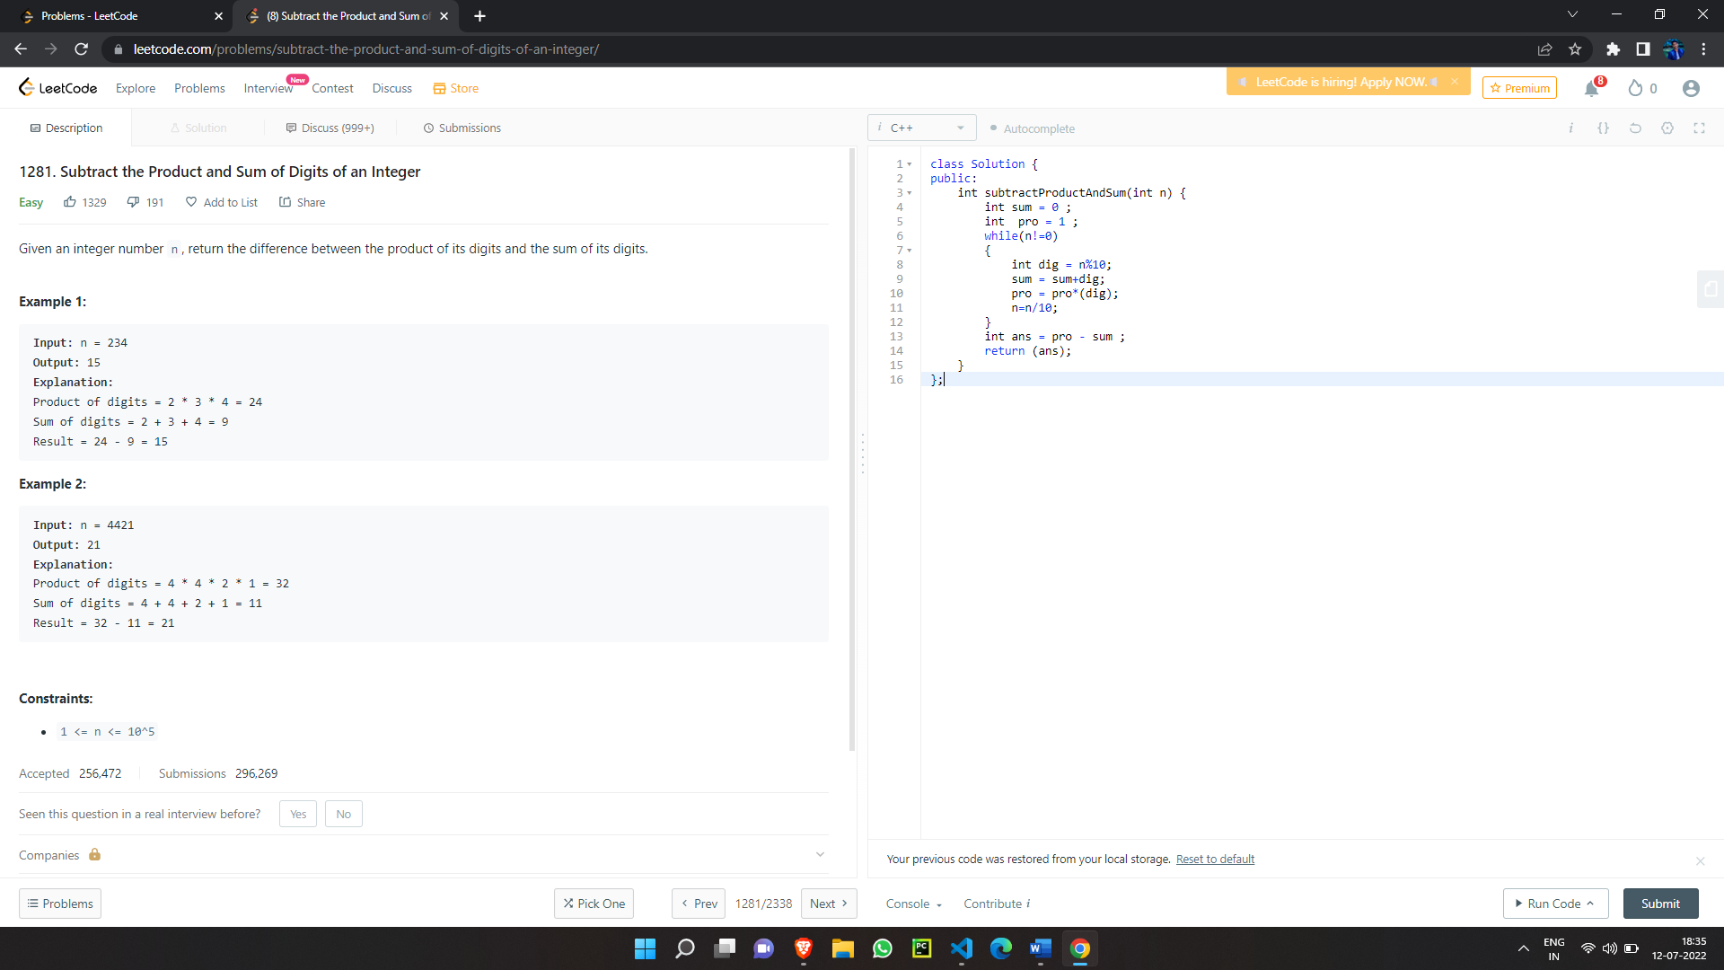

2.Number of 1 Bit in the number

<https://leetcode.com/problems/number-of-1-bits/>

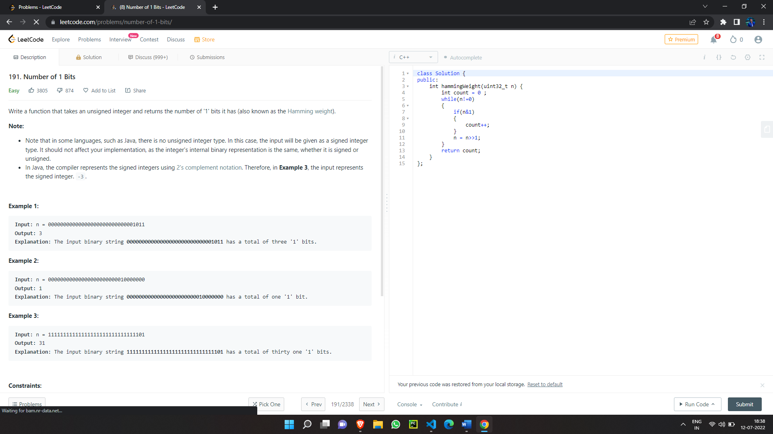

Lecture no 7 . Leet code problem solving session

1.Reverse the integer

<https://leetcode.com/problems/reverse-integer/>

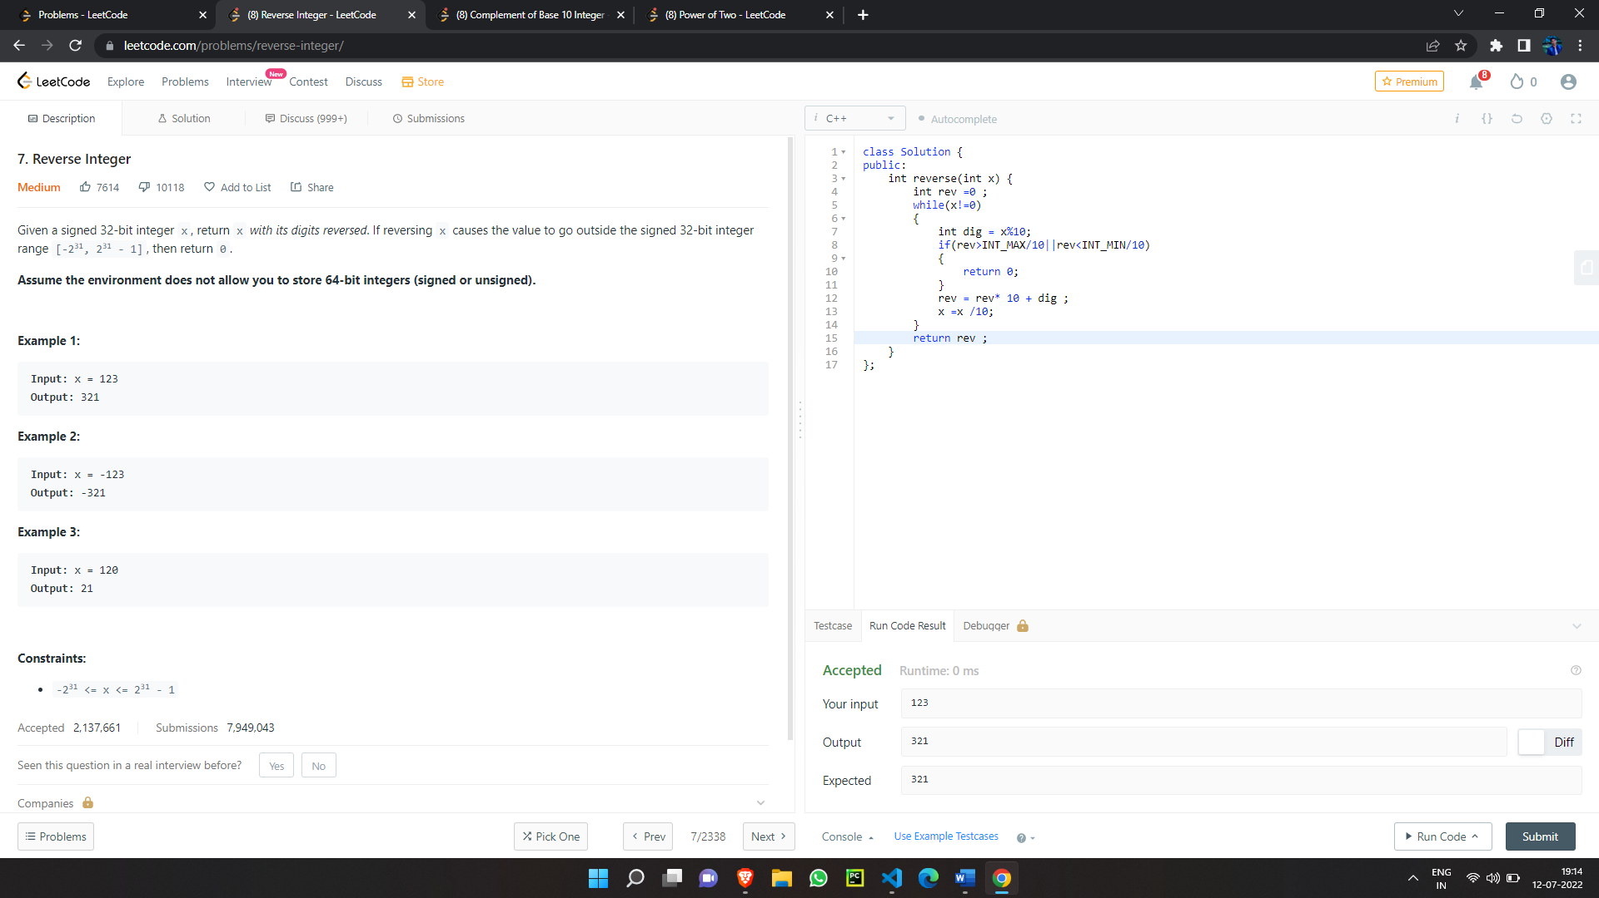

2.Complement of base 10 integer

<https://leetcode.com/problems/complement-of-base-10-integer/>

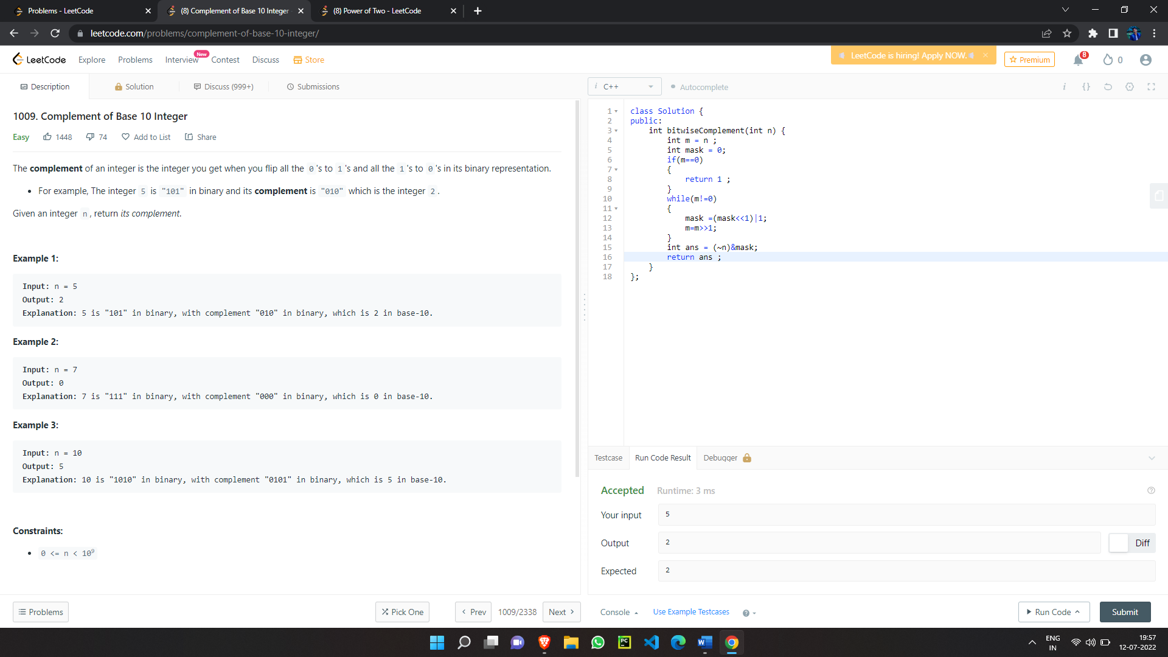

1. Power of two

<https://leetcode.com/problems/power-of-two/>

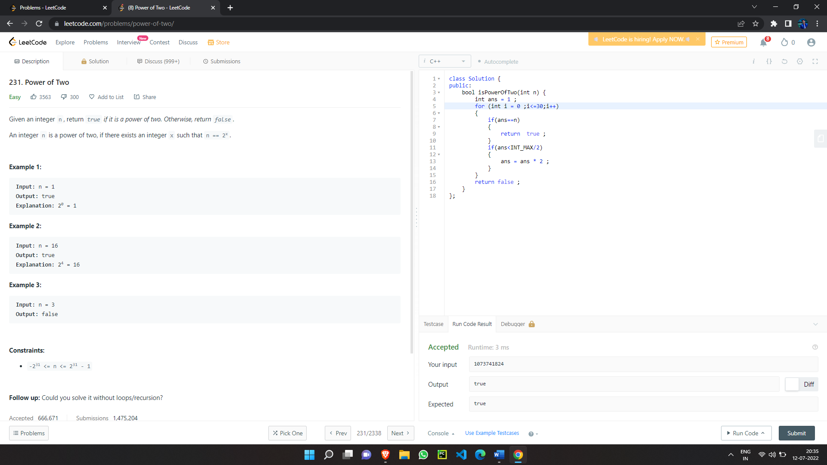

LECTURE NO . 10 . Solve leet code , code studio Question [array]

1. Find Unique element

https://www.codingninjas.com/codestudio/problems/find-unique_625159?source=youtube&campaign=love_babbar_codestudio1&utm_source=youtube&utm_medium=affiliate&utm_campaign=love_babbar_codestudio1

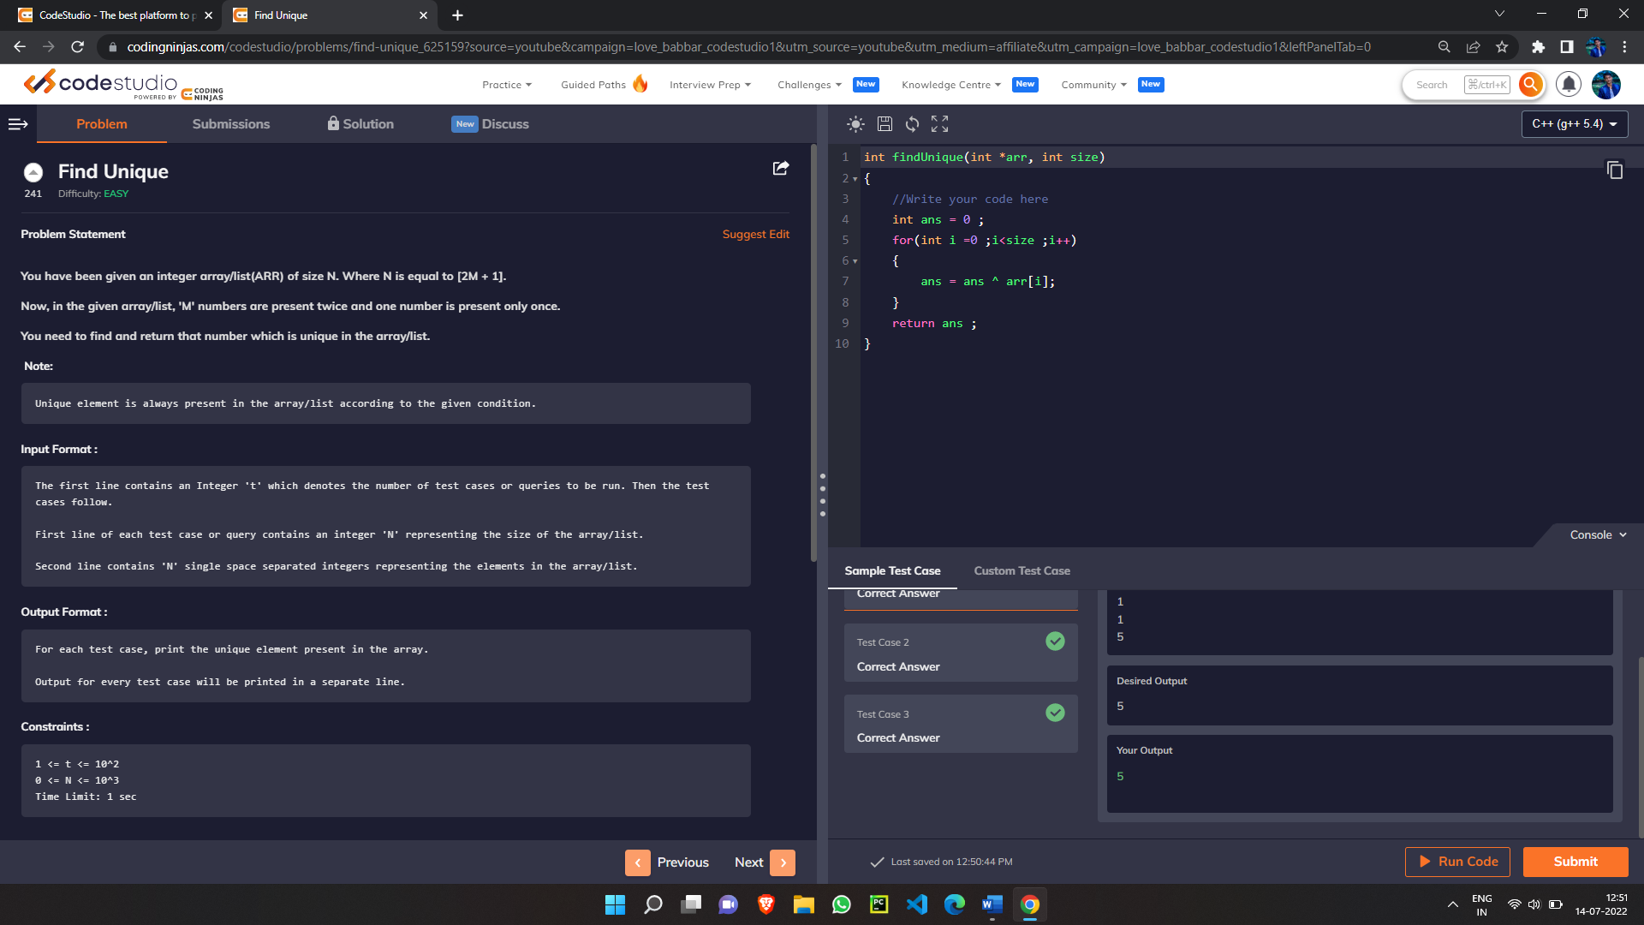

Home work : Unique number of occurrence

<https://leetcode.com/problems/unique-number-of-occurrences/>

1. Duplicates in Array

https://www.codingninjas.com/codestudio/problems/duplicate-in-array_893397?source=youtube&campaign=love_babbar_codestudio1&utm_source=youtube&utm_medium=affiliate&utm_campaign=love_babbar_codestudio1

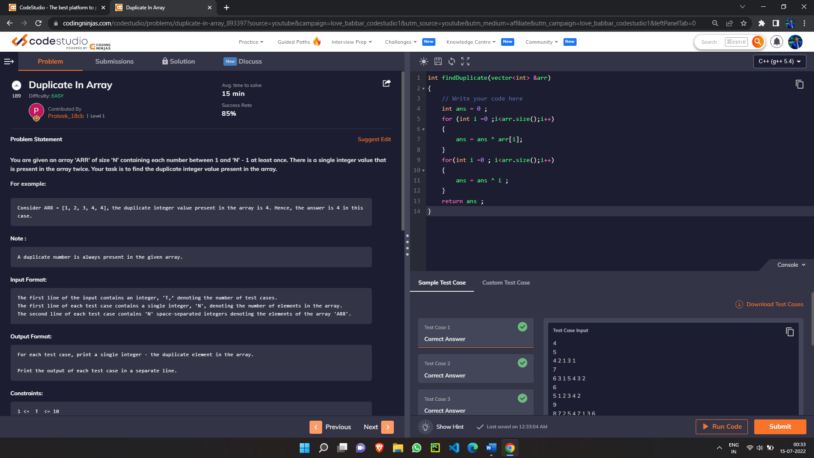

Home work : Find all duplicate elements of an array

<https://leetcode.com/problems/find-all-duplicates-in-an-array/>

1. Array Intersection

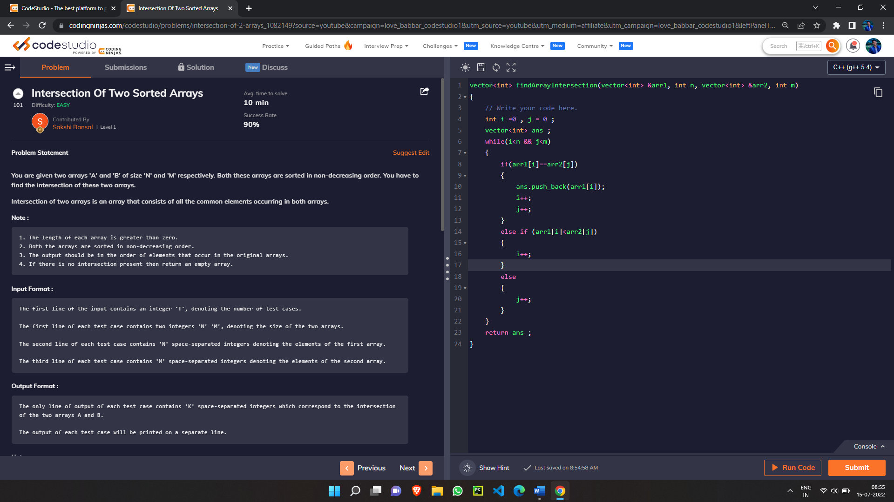 https://www.codingninjas.com/codestudio/problems/intersection-of-2-arrays_1082149?source=youtube&campaign=love_babbar_codestudio1&utm_source=youtube&utm_medium=affiliate&utm_campaign=love_babbar_code studio1

1. Pair Sum

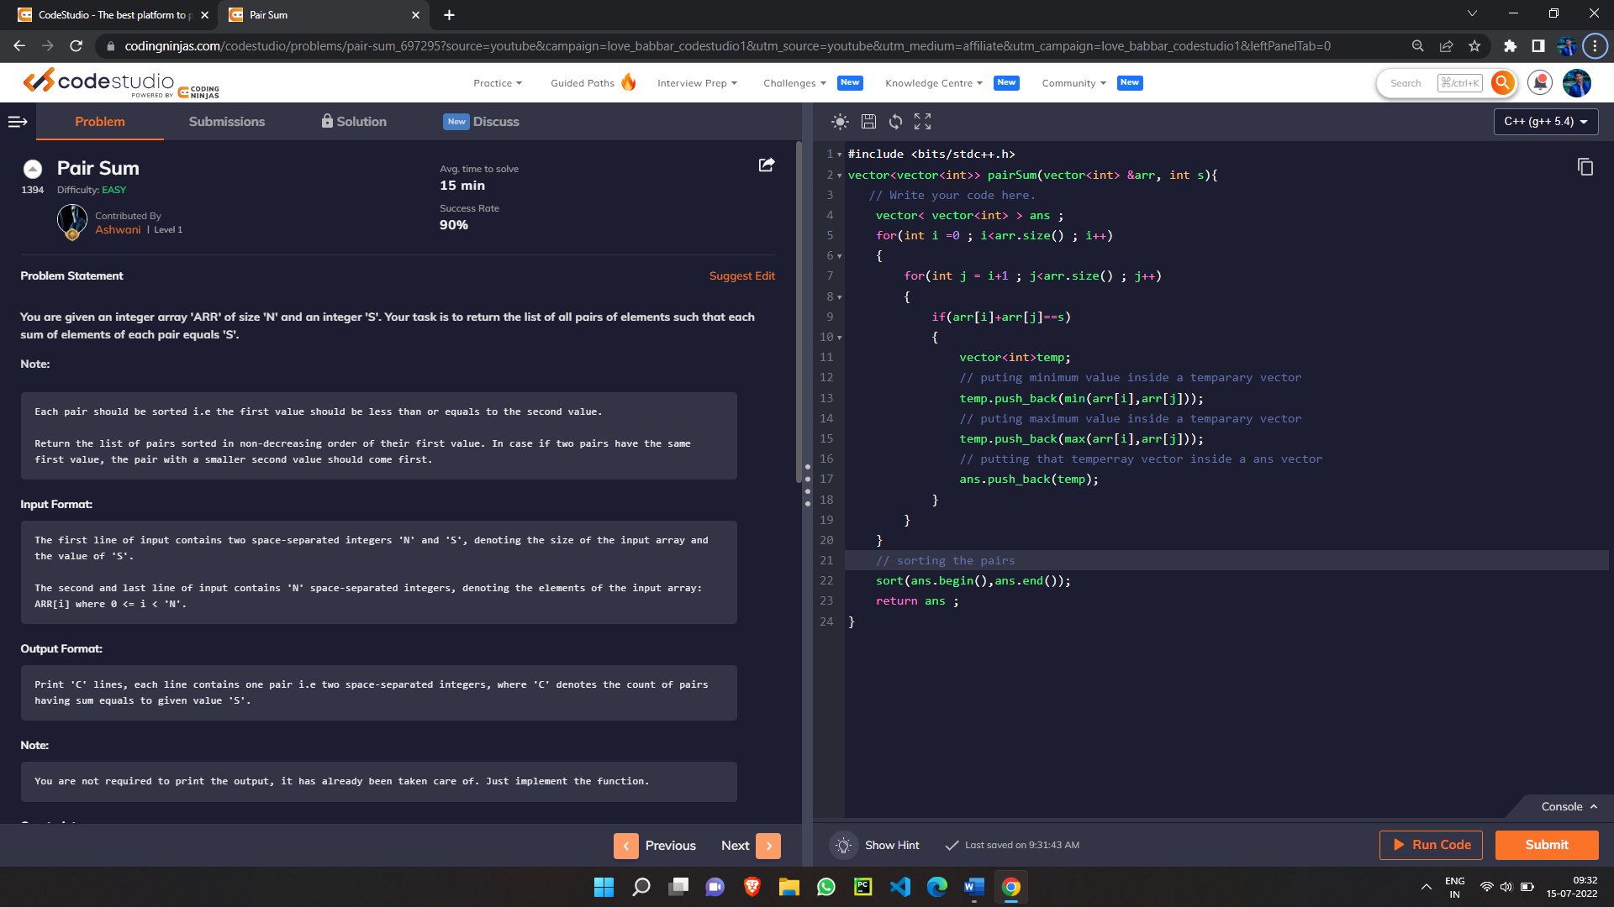 https://www.codingninjas.com/codestudio/problems/pair-sum_697295?source=youtube&campaign=love_babbar_codestudio1&utm_source=youtube&utm_medium=affiliate&utm_campaign=love_babbar_codestudio1

1. Triplet sum

https://www.codingninjas.com/codestudio/problems/triplets-with-given-sum_893028?source=youtube&campaign=LoveBabbar_Codestudiovideo1&utm_source=youtube&utm_medium=affiliate&utm_campaign=LoveBabb ar_Codestudiovideo1

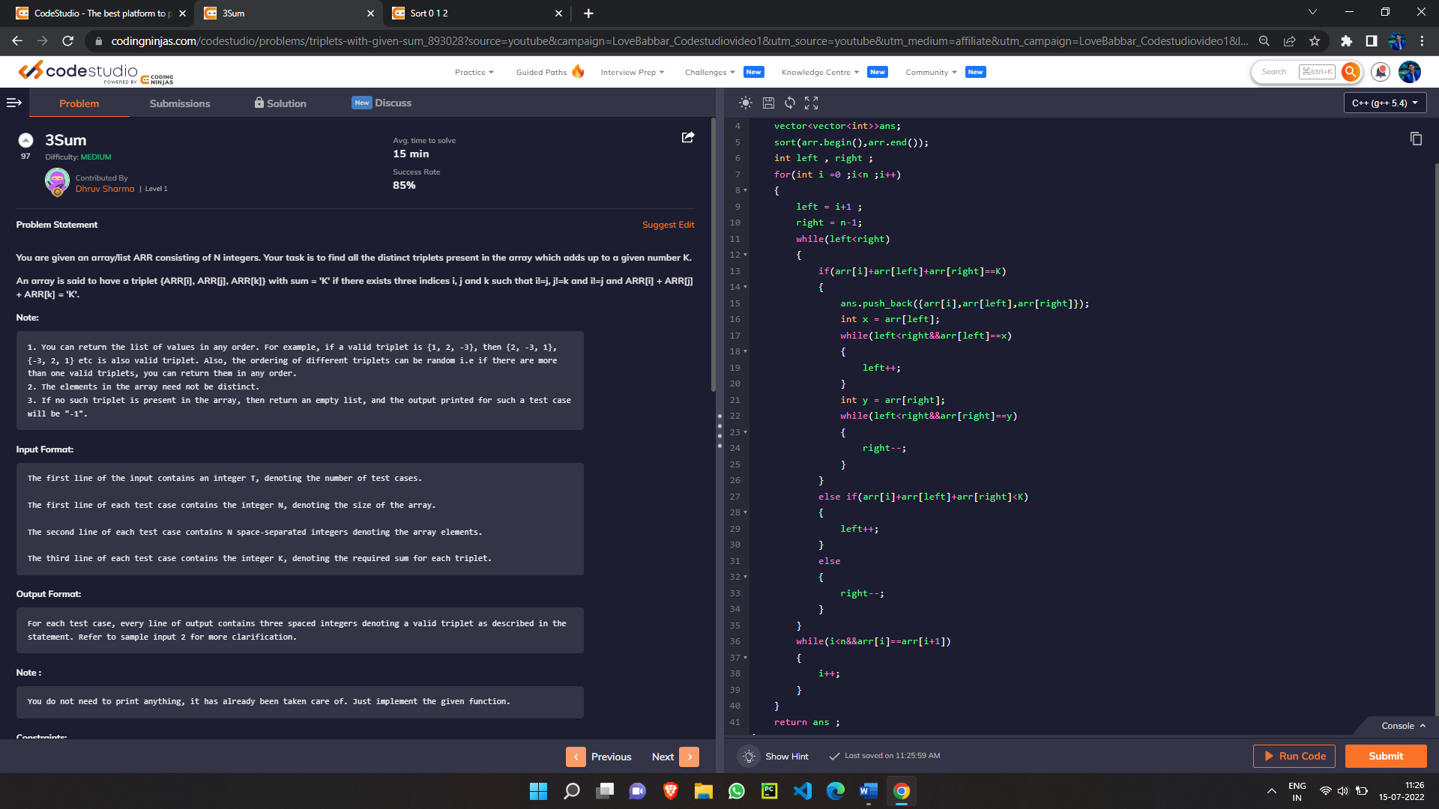

1. Sort 0 1 2

https://www.codingninjas.com/codestudio/problems/sort-0-1-2_631055?source=youtube&campaign=LoveBabbar_Codestudiovideo1&utm_source=youtube&utm_medium=affiliate&utm_campaign=LoveBabbar_Codestudiovideo1